

# 

### Semester Two Examination, 2020

### Question/Answer booklet

# MATHEMATICS

If required by your examination administrator, please place your student identification label in this box

**APPLICATIONS**

**UNITS 3&4**

## Section Two:

## Calculator-assumed

Your name _____________________________________

## Teacher’s Name _________________________________

## Time allowed for this section

Reading time before commencing work: ten minutes

Working time: one hundred minutes

## Materials required/recommended for this section

***To be provided by the supervisor***

This Question/Answer booklet

Formula sheet (retained from Section One)

***To be provided by the candidate***

Standard items: pens (blue/black preferred), pencils (including coloured), sharpener,  
correction fluid/tape, eraser, ruler, highlighters

Special items: drawing instruments, templates, notes on two unfolded sheets of A4 paper, and up to three calculators approved for use in this examination

## Important note to candidates

No other items may be taken into the examination room. It is **your** responsibility to ensure that you do not have any unauthorised material. If you have any unauthorised material with you, hand it to the supervisor **before** reading any further.

## Structure of this paper

|  |  |  |  |  |  |
| --- | --- | --- | --- | --- | --- |
| Section | Number of questions available | Number of questions to be answered | Working time (minutes) | Marks available | Percentage of examination |
| Section One: Calculator-free | 8 | 8 | 50 | 52 | 35 |
| Section Two: Calculator-assumed | 13 | 13 | 100 | 98 | 65 |
|  | | |  | **Total** | 100 |

|  |  |  |
| --- | --- | --- |
| Markers use only | | |
| Question | Maximum | Mark |
| 9 | 5 |  |
| 10 | 6 |  |
| 11 | 6 |  |
| 12 | 7 |  |
| 13 | 7 |  |
| 14 | 10 |  |
| 15 | 7 |  |
| 16 | 8 |  |
| 17 | 11 |  |
| 18 | 10 |  |
| 19 | 7 |  |
| 20 | 7 |  |
| 21 | 7 |  |
| S2 Total | 98 |  |
| S2 Wt (×0.6633) | 65% |  |

## Instructions to candidates

1. The rules for the conduct of examinations are detailed in the school handbook. Sitting this examination implies that you agree to abide by these rules.

2. Write your answers in this Question/Answer booklet preferably using a blue/black pen.  
Do not use erasable or gel pens.

3. You must be careful to confine your answers to the specific question asked and to follow any instructions that are specific to a particular question.

4. Show all your working clearly. Your working should be in sufficient detail to allow your answers to be checked readily and for marks to be awarded for reasoning. Incorrect answers given without supporting reasoning cannot be allocated any marks. For any question or part question worth more than two marks, valid working or justification is required to receive full marks. If you repeat any question, ensure that you cancel the answer you do not wish to have marked.

5. It is recommended that you do not use pencil, except in diagrams.

6. Supplementary pages for planning/continuing your answers to questions are provided at the end of this Question/Answer booklet. If you use these pages to continue an answer, indicate at the original answer where the answer is continued, i.e. give the page number.

7. The Formula sheet is not to be handed in with your Question/Answer booklet.

Section Two: Calculator-assumed 65% (98 Marks)

This section has**thirteen** questions. Answer **all** questions. Write your answers in the spaces provided.

Working time: 100 minutes.

Question 9 (5 marks)

The weights on the edges of the graph below are the flight times in hours between adjacent airports, represented by the vertices numbered $1$ to $9$.

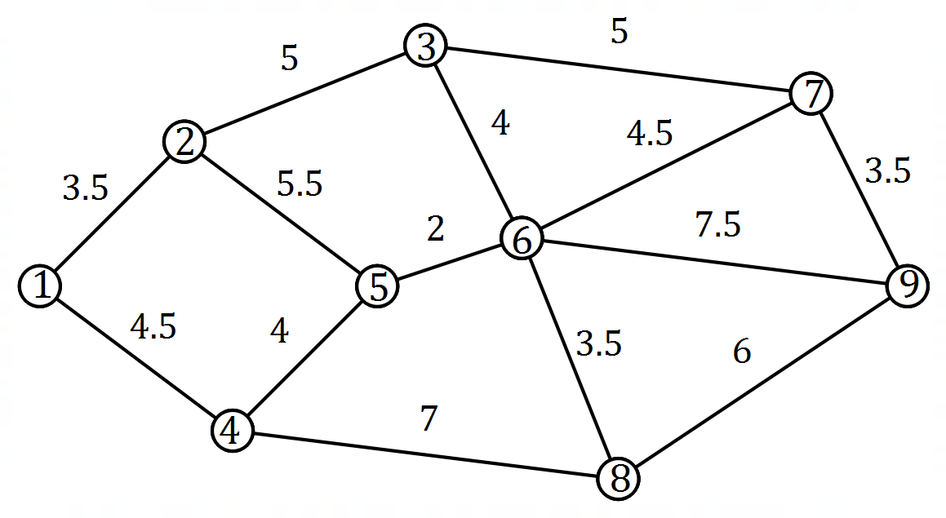

(a) Determine the minimum total flight time between airport $1$ and airport $9$. (2 marks)

(b) When planning a journey, a traveller allows $90$ minutes at each airport on their route, including the first and last, to allow for check in, transfers, baggage collection and so on. Determine the quickest route for this traveller from airport $1$ to airport $9$ and state their total journey time. (3 marks)

Question 10 (6 marks)

Using the declining balance method of depreciation, the value of an industrial machine at the end of its first year of use (year $1$) is $\$40 800$ and at the end of year $2$ is $\$34 680$.

The value of the machine in dollars at the end of year $n$ can be modelled by the recurrence relation $V_{n}=0.85V_{n}, V_{1}=40 800$.

(a) Show mathematically how to derive the value $0.85$ in the recurrence relation from information in the question. (1 mark)

(b) Write the rule for the $n^{th}$ term of this sequence. (1 mark)

(c) At the end of which year is the machine first valued at less than $\$7 500$? Justify your answer. (2 marks)

(d) Determine the value of the machine when it was new (at the start of the first year) and hence calculate its total decline in value, to the nearest dollar, over its first five years of use. (2 marks)

Question 11 (6 marks)

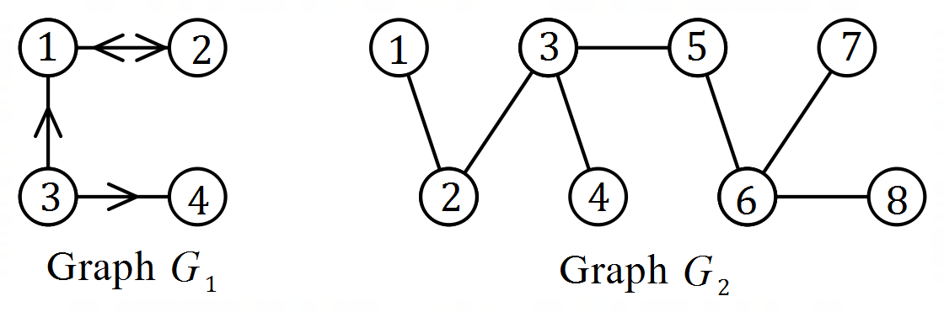(a) Connected graphs $G_{1}$ and $G_{2}$ 
 are shown at right.  
  
The adjacency matrices for $G_{1}$ 
 and $G_{2}$ are $A_{1}$ and $A_{2}$  
respectively.

(i) Construct matrix $A_{1}$. (2 marks)

(ii) Determine the number of entries in $A_{2}$ that are $0$. (2 marks)

(b) The adjacency matrix for graph $G_{3}$ is $\left[\begin{matrix}0 & 0 & 1 & 1 \\ 1 & 0 & 2 & 0 \\ 1 & 1 & 0 & 1 \\ 1 & 2 & 1 & 0\end{matrix} \right]$.  
  
State, with justification, whether $G_{3}$ is a simple graph. (2 marks)

Question 12 (7 marks)

The temperature $T_{n}$, in degrees Celsius, of an oven $n$ minutes after being turned on can be modelled by the recurrence relation $T_{n+1}=0.8T_{n}+43, T_{0}=20$.

(a) Use the recurrence relation to complete the following table to the nearest degree Celsius.

(2 marks)

|  |  |  |  |  |  |  |
| --- | --- | --- | --- | --- | --- | --- |
| $$n$$ | $$0$$ | $$1$$ | $$2$$ | $$3$$ | $$4$$ | $$5$$ |
| $$T_{n}$$ |  |  |  |  |  |  |

(b) Plot the temperature of the oven at one minute intervals on the axes below. (2 marks)

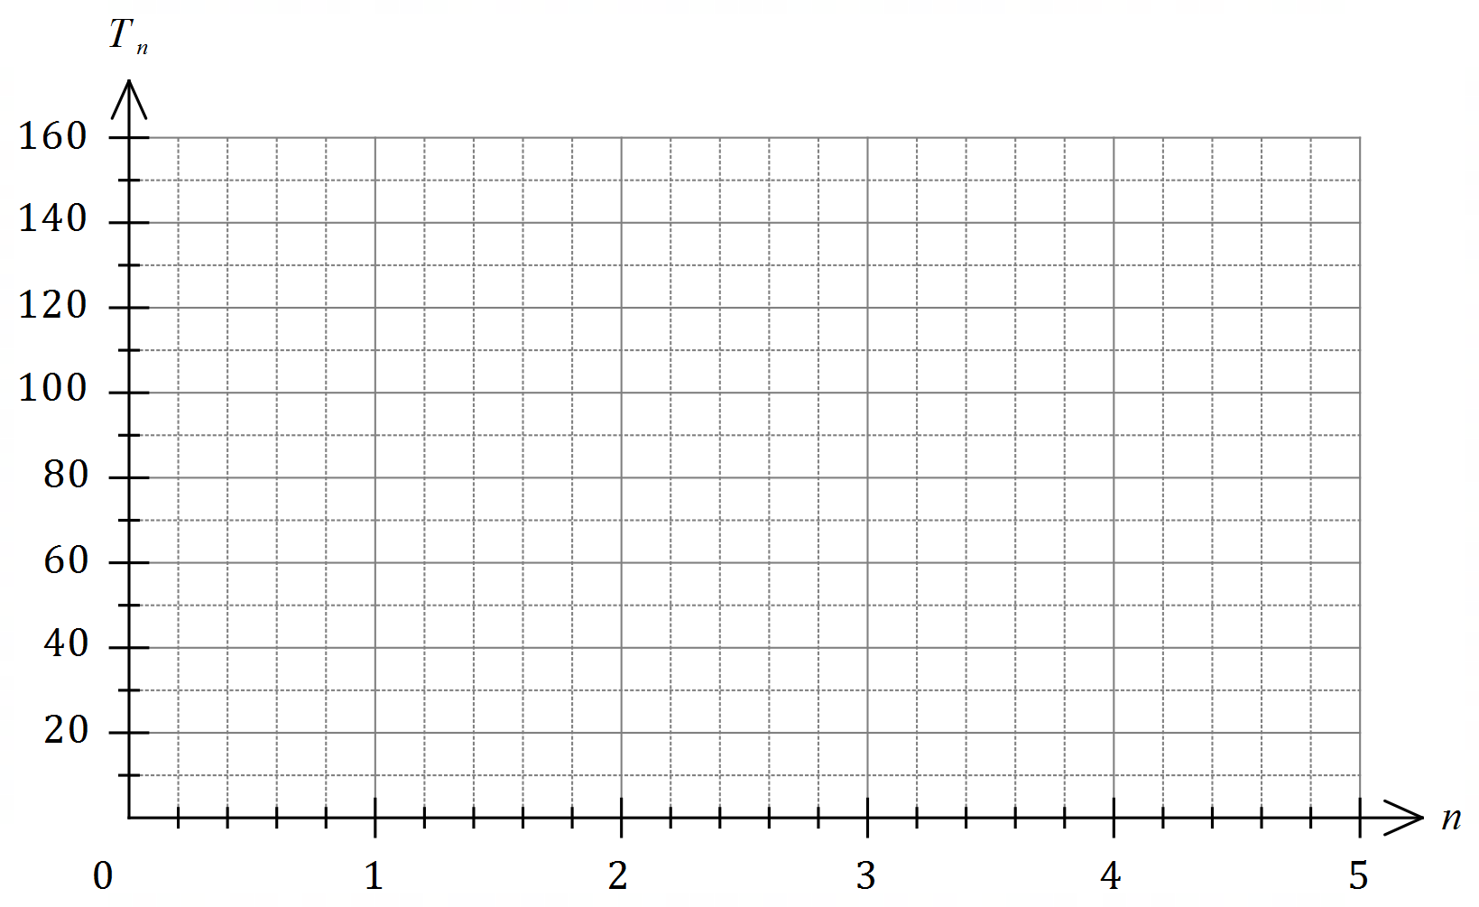

(c) State the value of $n$ for which the temperature of the oven first exceeds $200 °C$. (1 mark)

(d) Explain how the temperature of the oven changes in the long term. (2 marks)

Question 13 (7 marks)

A person has a credit card account with an outstanding debt of $\$2 883$ and the card provider charges interest at a rate of $14.49\%$ per annum compounded daily.

(a) Determine their card debt in $30$ days' time if the card is not used for any more purchases and no repayments are made. (2 marks)

The person can pay off their card debt using an unsecured loan from their bank at an interest rate of $14.6\%$ compounded monthly.

(b) Use effective interest rates to determine, with reasoning, whether the unsecured loan would be a better option for this person. (3 marks)

The person chose to pay off their card debt in full by taking out a two year secured loan for $\$2 883$ from a lender who compounds interest quarterly. At the end of this time, the person must repay the principal and interest, a sum of $\$3 417.84$.

(c) Determine the interest rate charged by this lender. (2 marks)

Question 14 (10 marks)

A factory operates three consecutive eight-hour shifts A, B and C each day. The table below shows the number of workers who turned up late for each shift, together with a three-point moving average $m$.

|  |  |  |  |  |
| --- | --- | --- | --- | --- |
| Time period $t$ | Day | Shift | Number late | Moving average $m$ |
| $$1$$ | Sun | A | $$47$$ | $$-$$ |
| $$2$$ | Sun | B | $$35$$ | $$P$$ |
| $$3$$ | Sun | C | $$41$$ | $$40$$ |
| $$4$$ | Mon | A | $$44$$ | $$37$$ |
| $$5$$ | Mon | B | $$26$$ | $$36$$ |
| $$6$$ | Mon | C | $$38$$ | $$35$$ |
| $$7$$ | Tue | A | $$41$$ | $$35$$ |
| $$8$$ | Tue | B | $$26$$ | $$34$$ |
| $$9$$ | Tue | C | $$Q$$ | $$-$$ |

(a) Briefly describe the purpose of calculating a set of moving averages for a time series.

(1 mark)

(b) Determine the value of $P$ and the value of $Q$ in the table above. (2 marks)

(c) Determine the centred six-point moving average for $t=4$. (2 marks)

(d) Determine the least-squares line to predict $m$ from $t$. (2 marks)

Two of the seasonal indices for the above time series are shown in the table below.

|  |  |  |  |
| --- | --- | --- | --- |
| Shift | A | B | C |
| Seasonal index | $$1.19$$ | $$0.78$$ |  |

(e) Calculate the seasonal index for shift C. (1 mark)

(f) Forecast the number of late workers for the next B shift (on Wednesday), using the  
least-squares line from (d) and making any necessary seasonal adjustment. (2 marks)

Question 15 (7 marks)

On $1$ March $2020$ Dea started a new job with an annual salary of $\$72 000$. At that time, the balance of her superannuation fund from previous jobs was $\$53 520$. Dea's new employer deposits a sum equal to $9.25\%$ of her monthly salary into her fund on the last day of each month.

Interest on the balance of an individual's superannuation fund is added on the last day of each month, just before any deposits are made, and the fund advertises an interest rate of $5.4\%$ per annum.

(a) Determine the balance of Dea's superannuation fund on $1$ April $2020$. (3 marks)

(b) Write a recursive relation for the balance $T_{n}$ of Dea's superannuation fund $n$ months after she started her new job. (2 marks)

(c) Calculate the expected increase in the balance of Dea's superannuation fund after she has been in her new job for one year if her circumstances do not change. (2 marks)

Question 16 (8 marks)

The records of $261$ people who were hospitalised with an injury following a road accident have been categorised by road user group and main body region injured in the table below.

|  |  |  |  |  |
| --- | --- | --- | --- | --- |
|  | Shoulder | Head | Lower limb | Neck |
| Motorcyclist | $$23$$ | $$7$$ | $$15$$ | $$2$$ |
| Car occupant | $$49$$ | $$74$$ | $$28$$ | $$63$$ |

(a) Determine what percentage of those hospitalised were motorcyclists. (1 mark)

(b) State the most common main body region injured by motorcyclists and what percentage of motorcyclists had this body region recorded as their main injury. (2 marks)

(c) Complete the following table of row percentages, rounding to the nearest whole number.

(3 marks)

|  |  |  |  |  |
| --- | --- | --- | --- | --- |
| (%) | Shoulder | Head | Lower limb | Neck |
| Motorcyclist |  | $$15$$ |  |  |
| Car occupant |  | $$35$$ |  |  |

(d) Do the records suggest the presence of an association between the categorical variables? Justify your answer. (2 marks)

Question 17 (11 marks)

The table below shows the percentage of all trips made using a bicycle $x$ and a car $y$ for nine countries. The correlation coefficient for the set of data is $-0.89$.

|  |  |  |  |  |  |  |  |  |  |
| --- | --- | --- | --- | --- | --- | --- | --- | --- | --- |
| Country | $$A$$ | $$B$$ | $$C$$ | $$D$$ | $$E$$ | $$F$$ | $$G$$ | $$H$$ | $$I$$ |
| Bicycle trips, $x$ ($\%$) | $$4$$ | $$1$$ | $$12$$ | $$5$$ | $$8$$ | $$2$$ | $$11$$ | $$10$$ | $$7$$ |
| Car trips, $y$ ($\%$) | $$63$$ | $$84$$ | $$49$$ | $$67$$ | $$55$$ | $$74$$ | $$36$$ | $$38$$ | $$42$$ |

(a) Add the three missing points to the scatterplot below. (2 marks)

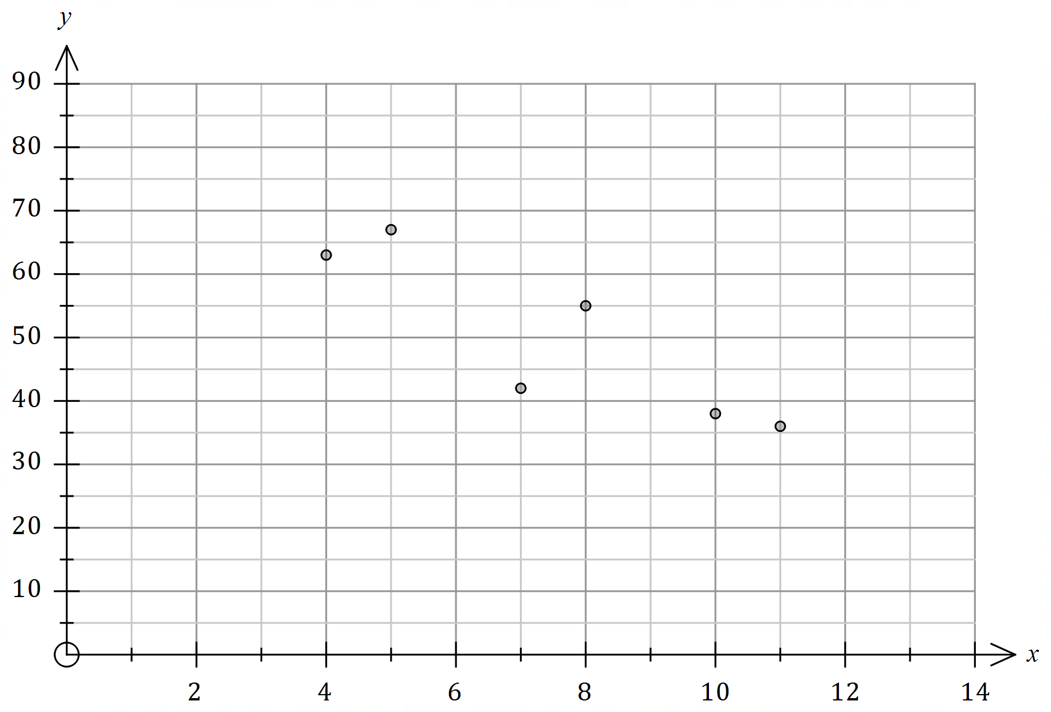

(b) A journalist discussed the dataset in an article with the headline "Decreasing bicycle use causes increase use of cars". Comment on their choice of headline. (2 marks)

(c) Determine the equation of the least-squares line with $x$ as the explanatory variable.

(2 marks)

(d) In the context of the question, interpret

(i) the intercept of the least-squares line. (1 mark)

(ii) the slope of the least-squares line. (1 mark)

(e) In country $K$, $15\%$ of all trips are made by bicycle. Predict the percentage of trips made using a car in this country and discuss factors related to the use of the fitted line that affect your confidence in this prediction. (3 marks)

Question 18 (10 marks)

Data for the number of regional home sales per quarter, rounded to the nearest hundred homes, is shown in the table below.

|  |  |  |  |  |  |
| --- | --- | --- | --- | --- | --- |
| $$t$$ | Year | Quarter | Sales ($h$), in hundreds | Quarterly mean | Sales as percentage of quarterly mean |
| $$1$$ | $$2011$$ | $$1$$ | $$56$$ | $$A$$ | $$92.9$$ |
| $$2$$ | $$2$$ | $$61$$ | $$101.2$$ |
| $$3$$ | $$3$$ | $$59$$ | $$97.9$$ |
| $$4$$ | $$4$$ | $$65$$ | $$107.9$$ |
| $$5$$ | $$2012$$ | $$1$$ | $$64$$ | $$74.0$$ | $$86.5$$ |
| $$6$$ | $$2$$ | $$76$$ | $$102.7$$ |
| $$7$$ | $$3$$ | $$74$$ | $$100$$ |
| $$8$$ | $$4$$ | $$82$$ | $$B$$ |
| $$9$$ | $$2013$$ | $$1$$ | $$79$$ |  | $$94.3$$ |
| $$10$$ | $$2$$ | $$91$$ | $$108.7$$ |
| $$11$$ | $$3$$ | $$80$$ | $$95.5$$ |
| $$12$$ | $$4$$ | $$C$$ | $$101.5$$ |

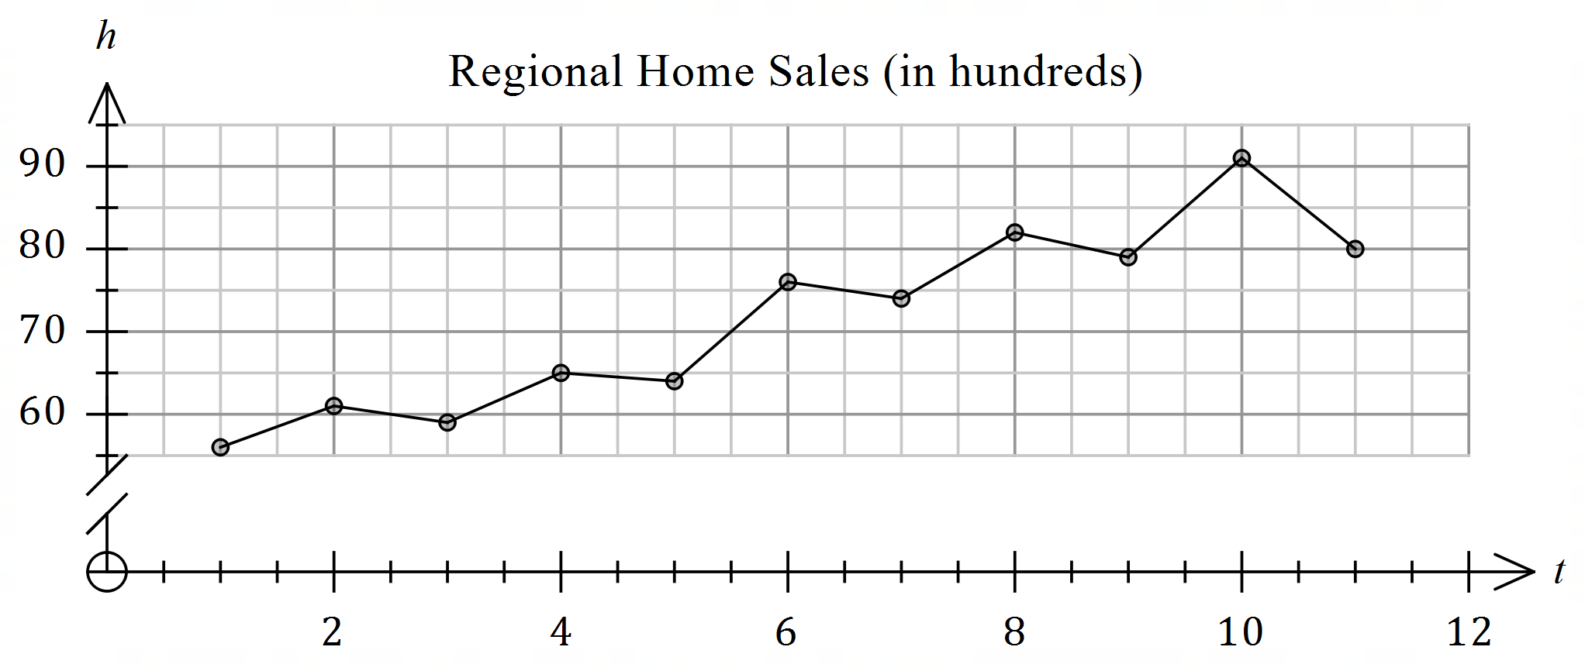

(a) Describe the trend and seasonality of this data. (2 marks)

(b) Calculate the value of $A$, the value of $B$ and the value of $C$ in the table. (4 marks)

(c) Determine the deseasonalised number of home sales in the region in the first quarter of $2013$. (3 marks)

(d) Forecast the actual number of home sales in the region for the first quarter of $2014$ given that the least-squares trend line for the deseasonalised data indicates that the number of home sales to be $8 880$ at that time. (1 mark)

Question 19 (7 marks)

A company took out a business loan of $\$125 000$ at an interest rate of $8.76\%$ per annum and made monthly repayments of $\$5 700$. The first few rows of a spreadsheet used by the company to track the loan balance is shown below.

|  |  |  |  |  |
| --- | --- | --- | --- | --- |
| Month, $n$ | Balance at start of month $n$ | Interest | Repayment | Balance carried forward |
| $$1$$ | $$125 000.00$$ | $$912.50$$ | $$5 700.00$$ | $$120 212.50$$ |
| $$2$$ | $$120 212.50$$ | $$877.55$$ | $$5 700.00$$ | $$115 390.05$$ |
| $$3$$ | $$115 390.05$$ | $$A$$ | $$5 700.00$$ | $$B$$ |

(a) Determine the value of $A$ and the value of $B$ in the spreadsheet. (2 marks)

A recurrence relation of the form $T_{n+1}=rT_{n}-d, T_{1}=a$ can be used to model the balance of the loan at the start of month $n$.

(b) Determine the value of each of the constants $r, d$ and $a$ in the recurrence relation.

(2 marks)

(c) Using a financial calculator, or otherwise, state

(i) the balance of the loan after $9$ repayments. (1 mark)

(ii) the number of repayments required to repay the loan. (1 mark)

(iii) the minimum monthly repayment for the full amount of the loan to be repaid at the same interest rate in $12$ equal repayments. (1 mark)

Question 20 (7 marks)

Some consecutive terms of sequence $A$ are shown in the following table.

|  |  |  |  |  |  |
| --- | --- | --- | --- | --- | --- |
| $$n$$ | $$4$$ | $$5$$ | $$6$$ | $$7$$ | $$8$$ |
| $$A_{n}$$ | $$55$$ | $$49$$ | $$43$$ | $$37$$ | $$31$$ |

(a) State the name given to this type of sequence and determine $A_{1}$, the first term of the sequence. (2 marks)

(b) Determine a rule for the $n^{th}$ term of sequence $A$ in the form $A_{n}=m×n+c$, where $m$ and $c$ are both constants. (2 marks)

The $n^{th}$ term of another sequence that has a constant difference is $B_{n}$, so that $B_{4}=A_{17}$  
and $B_{10}=A_{12}$.

(c) Determine $B_{14}$. (3 marks)

Question 21 (7 marks)

The balance of a savings account $A_{n}$ after $n$ monthly deposits have been made can be modelled by $A_{n+1}=1.015A_{n}+200, A_{0}=2 400$.

(a) Determine

(i) the amount deposited each month. (1 mark)

(ii) the annual interest rate of the savings account. (1 mark)

(iii) the balance of the savings account after $4$ monthly deposits have been made.

(1 mark)

After the ${240}^{th}$ monthly deposit, no further deposits are made.

(b) Calculate the total interest that the savings account received up to this time. (2 marks)

The accumulated balance still attracts interest, compounded monthly at the same rate, and is used to fund an annual perpetuity.

(c) Determine the amount of the annual perpetuity. (2 marks)

Supplementary page

Question number: _________

© 2020 WA Exam Papers. Kennedy Baptist College has a non-exclusive licence to copy and communicate this document for non-commercial, educational use within the school. No other copying, communication or use is permitted without the express written permission of WA Exam Papers. SN245-166-2.